Full Stack App Deployment using Docker + AWS

Phase – 1 (Backend (Node.js)
Create a backend that can:
- Add task
- Get all tasks

Step 1: Create Project Folder
mkdir task-manager-backend
cd task-manager-backend
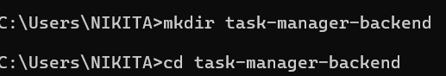

Step 2: Create app.js
Run: notepad app.js
paste this code
const http = require('http');

let tasks = [];

const server = http.createServer((req, res) => {
if (req.method === 'GET' && req.url === '/tasks') {
res.setHeader('Content-Type', 'application/json');
res.end(JSON.stringify(tasks));
}

else if (req.method === 'POST' && req.url === '/tasks') {
let body = '';

req.on('data', chunk => {
body += chunk.toString();
});

req.on('end', () => {
const task = JSON.parse(body);
tasks.push(task);

res.end("Task added");
});
}

else {
res.statusCode = 404;
res.end("Not Found");
}
});

server.listen(3000, () => {
console.log("Server running on port 3000");
});

Save and close.

Step 3: Create package.json

Run: notepad package.json

Paste this code

{
"name": "task-manager-backend",
"version": "1.0.0",
"main": "app.js"
}

Save and close.

Step 4: Testing (Using Docker)

- Create Dockerfile

notepad Dockerfile

Paste this code

FROM node:18-alpine
WORKDIR /app
COPY . .
EXPOSE 3000
CMD ["node", "app.js"]

Save and close

- Build Image

Run: docker build -t task-backend .

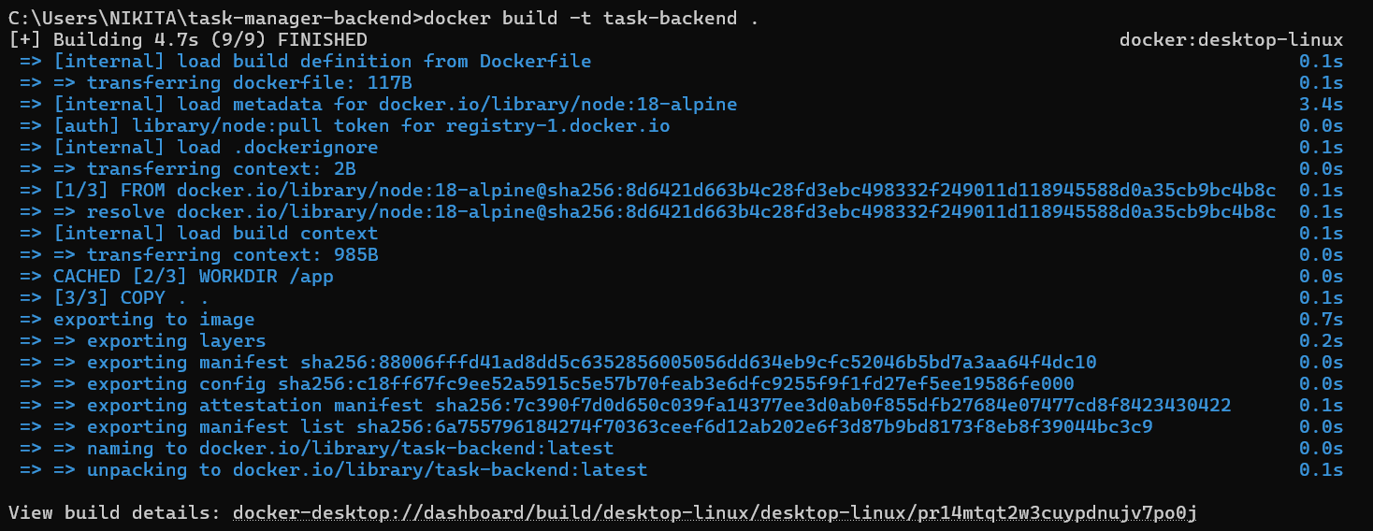

- Run Container

Run: docker run -d -p 3000:3000 task-backend

- Add task

curl -X POST http://localhost:3000/tasks -H "Content-Type: application/json" -d "{\"task\":\"Learn Docker\"}"

Step 5: Test API

Open browser:

http://localhost:3000/tasks

👉 Output:

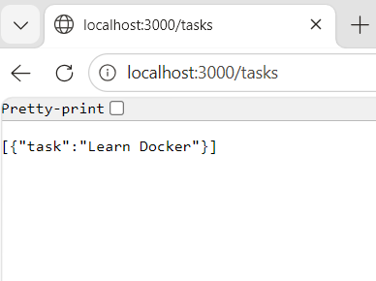

What we built
- Real backend API
- Running inside Docker
- Handles requests

This is actual backend service

Phase- 2 Database (MongoDB)

Store tasks in a database instead of memory

Step 1: Run MongoDB Container

Run: docker run -d -p 27017:27017 --name mongodb mongo

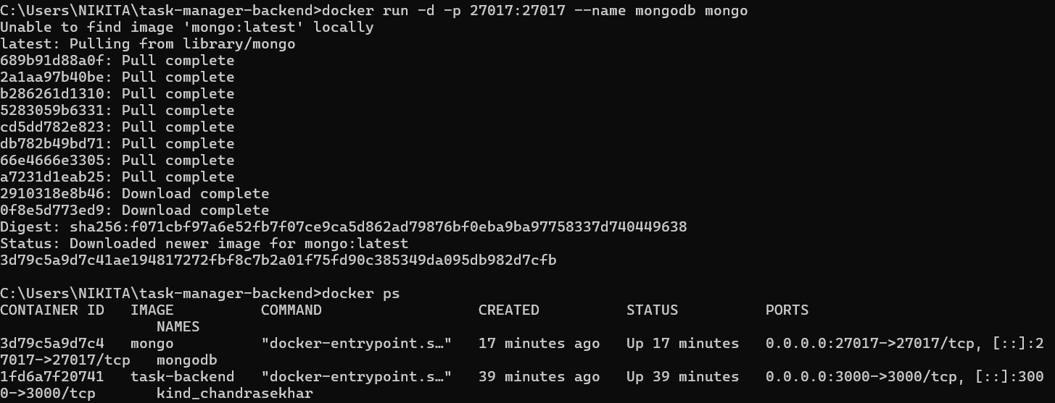

For Verify

Run: docker ps

Output: mongodb

Step 2: Update app.js

Replace your old code with this:

Open app.js

Paste this code

const http = require('http');
const { MongoClient } = require('mongodb');

const client = new MongoClient('mongodb://localhost:27017');

let db;

async function startServer() {
await client.connect();
db = client.db('taskdb');
const collection = db.collection('tasks');

const server = http.createServer(async (req, res) => {

if (req.method === 'GET' && req.url === '/tasks') {
const tasks = await collection.find().toArray();
res.setHeader('Content-Type', 'application/json');
res.end(JSON.stringify(tasks));
}

else if (req.method === 'POST' && req.url === '/tasks') {
let body = '';

req.on('data', chunk => {
body += chunk.toString();
});

req.on('end', async () => {
const task = JSON.parse(body);
await collection.insertOne(task);
res.end("Task added to DB");
});
}

else {
res.statusCode = 404;
res.end("Not Found");
}
});

server.listen(3000, () => {
console.log("Server running on port 3000");
});
}

startServer();

Save and close.
Step 3: Update package.json

Add MongoDB dependency:

{
"name": "task-manager-backend",
"version": "1.0.0",
"main": "app.js",
"dependencies": {
"mongodb": "^5.0.0"
}
}

Step 4: Update Dockerfile

FROM node:18-alpine

WORKDIR /app

COPY package.json .

RUN npm install

COPY . .

EXPOSE 3000

CMD ["node", "app.js"]

Step 5: Rebuild Image

Run: docker build -t task-backend .

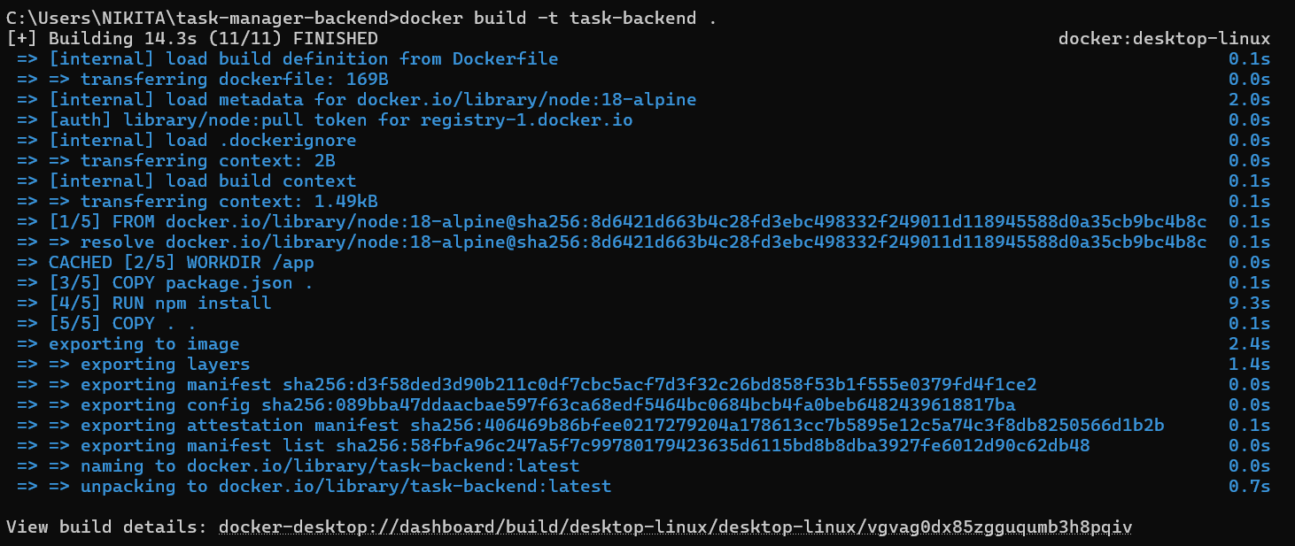

Step 6: Run Backend

docker run -d -p 3000:3000 task-backend

Step 7: Test

Add task:

curl -X POST http://localhost:3000/tasks -H "Content-Type: application/json" -d "{\"task\":\"Learn MongoDB\"}"

http://localhost:3000/tasks

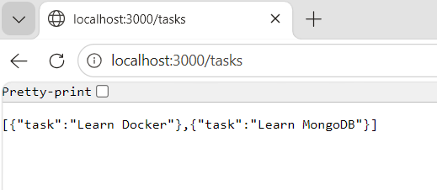

What we learned

- Connected backend to database
- Stored real data
- Used MongoDB inside Docker

Phase 3: Docker Compose (Connect Backend + Database)

Run multiple containers together:
- Backend (Node.js)
- Database (MongoDB)

Using one command only

Step 1: Create docker-compose.yml

Run: notepad docker-compose.yml

Paste this code

version: '3'

services:
backend:
build: .
ports:
- "3000:3000"
depends_on:
- mongo

mongo:
image: mongo
ports:
- "27017:27017"

Save and close

Step 2: Fix Backend Connection

Open app.js

Change this line:

OLD:
mongodb://localhost:27017

NEW:
mongodb://mongo:27017

Why this change:
- mongo = service name in compose
- Containers talk using service name (not localhost)

Step 3: Build & Run Everything

docker-compose up - -build

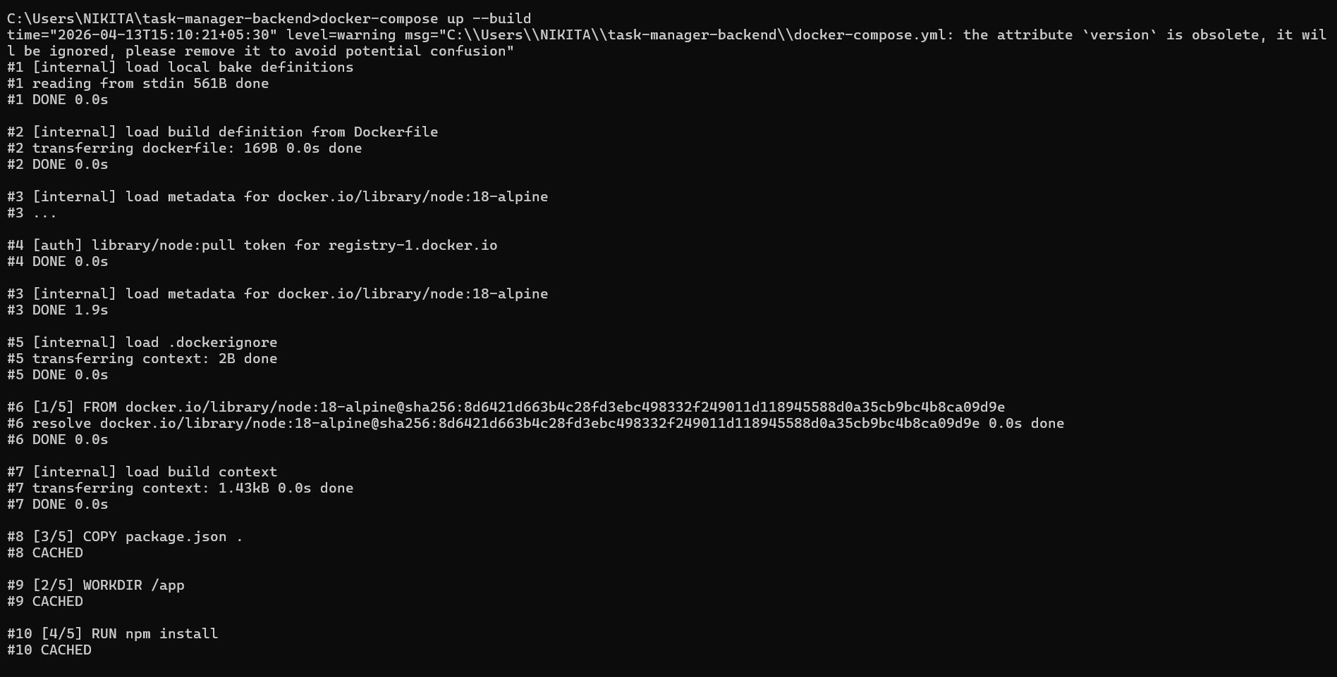
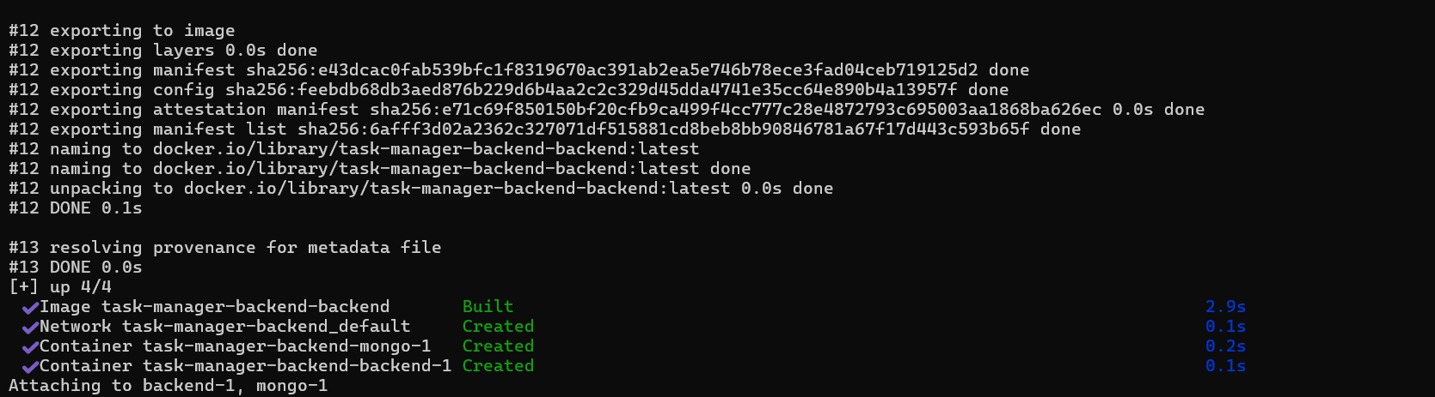

Docker will:
- Build backend image
- Start MongoDB container
- Connect both
- Run app

Step 4: Test

Add Task
curl -X POST http://localhost:3000/tasks -H "Content-Type: application/json" -d "{\"task\":\"Learn Docker Compose\"}"

Open:
http://localhost:3000/tasks

👉 Output:

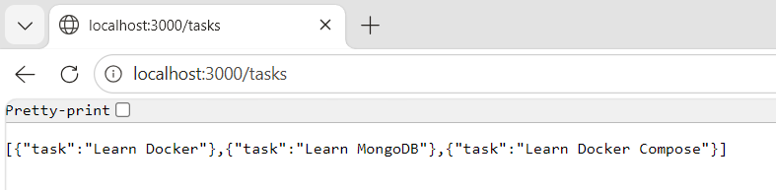

Phase – 4 (Deploy on Amazon Web Services (EC2)
Run your Docker project on a live cloud server
Step 1: Launch EC2 Instance

- Login to AWS
- Go to EC2 Dashboard
- Click Launch Instance
- Name: docker-project
- OS: Ubuntu
- Instance type: t3.micro (free tier)
- Key pair: create/download .pem file

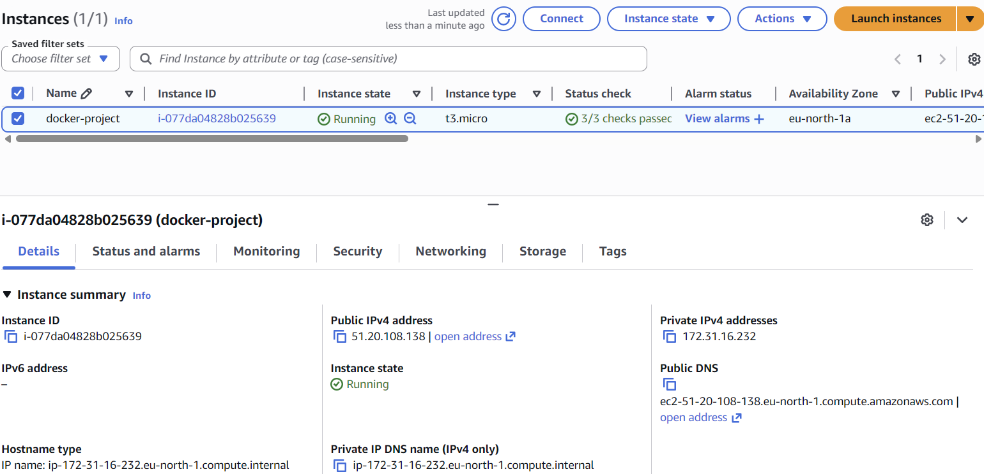

Step 2: Connect to Server

Open terminal: ssh -i "C:\Users\NIKITA\Downloads\docker-project.pem" ubuntu@51.20.108.138

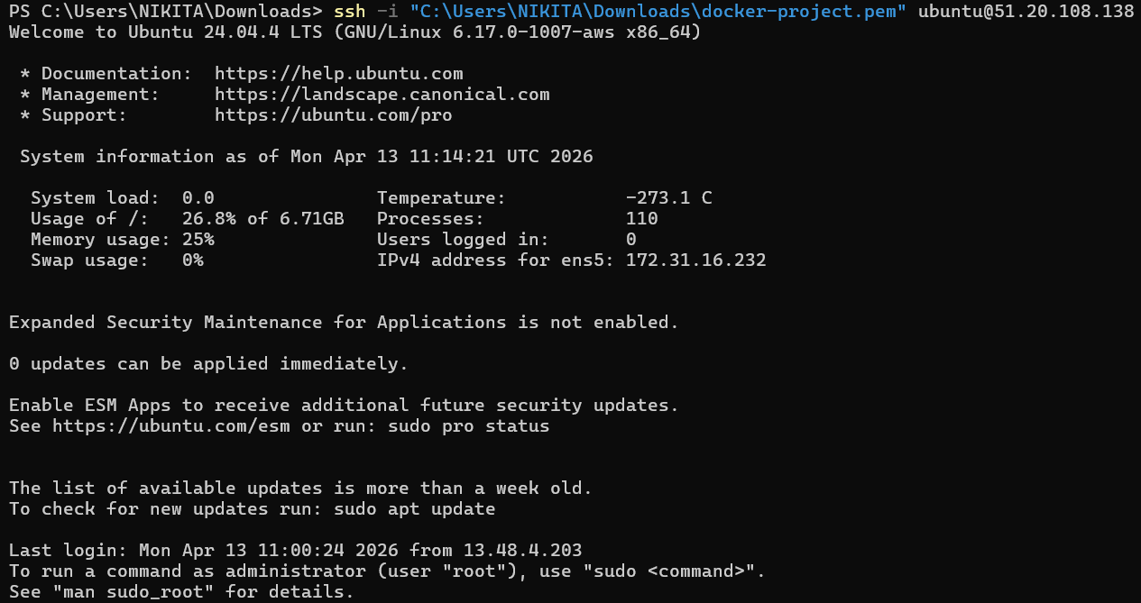
Step 3: Install Docker

Run:
sudo apt update
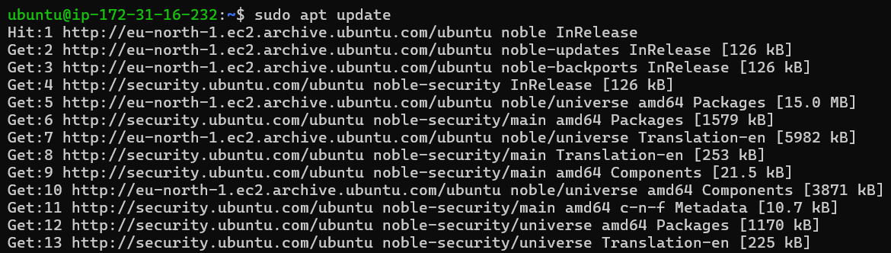

sudo apt install docker.io -y

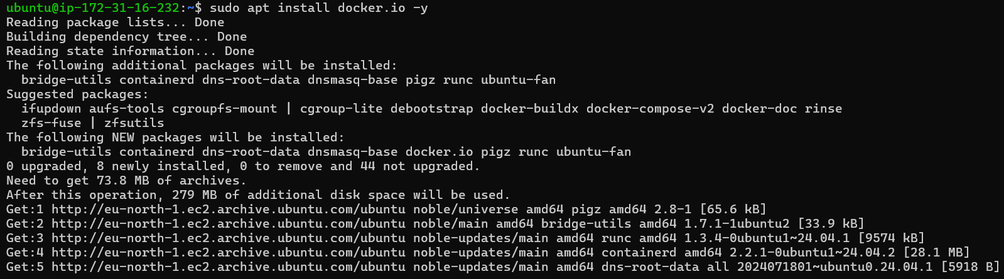

Start Docker:

sudo systemctl start docker
sudo systemctl enable docker

Step 4: Install Docker Compose

sudo apt install docker-compose -y

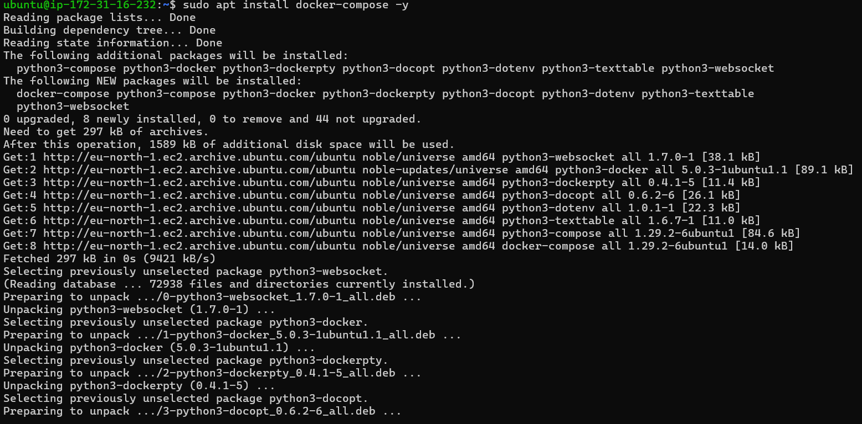

Step 5: Upload Your Project

Use Git:

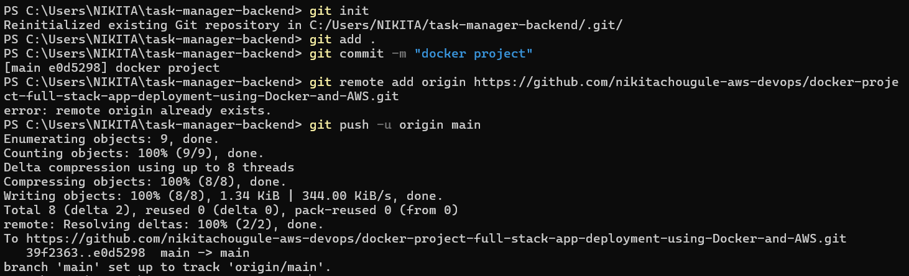

Step 6: Run Project

sudo docker-compose up -d --build

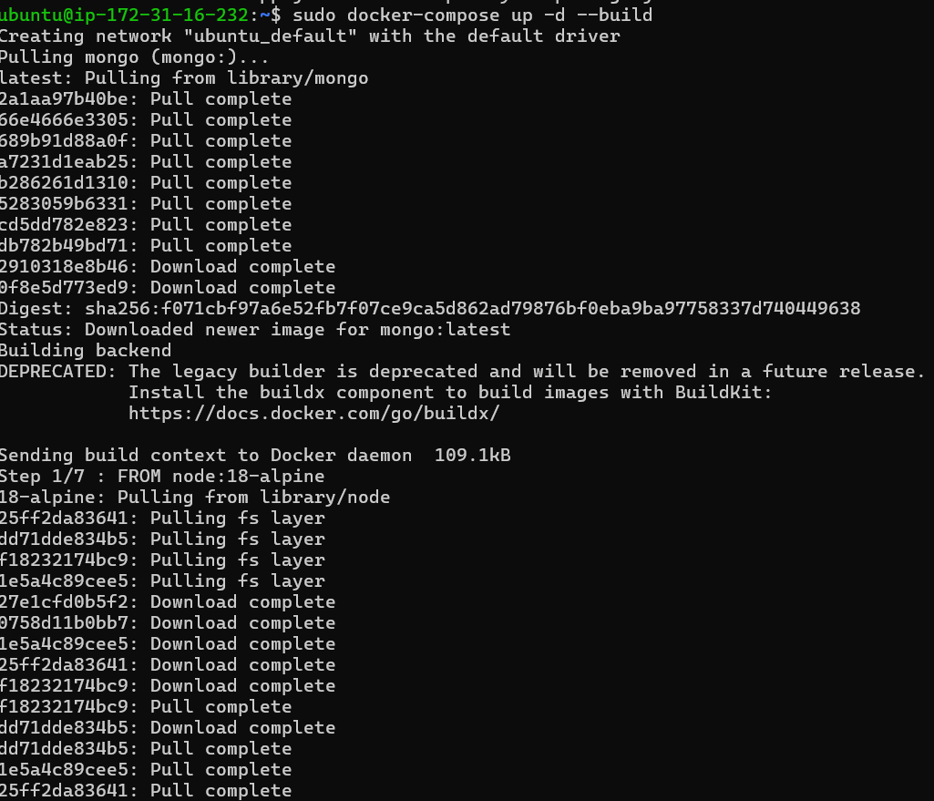

Step 7: Access Your App

Open browser:

http://51.20.108.138:3000/tasks

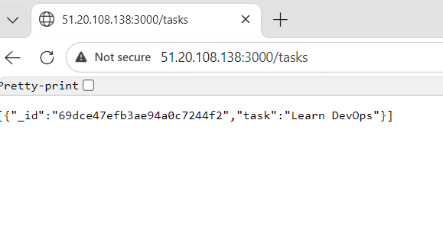

Step 8: Fix Security Group (IMPORTANT)

If not opening:
- Go to EC2 → Security Groups
- Add rule:
  - Type: Custom TCP
  - Port: 3000
  - Source: 0.0.0.0/0

